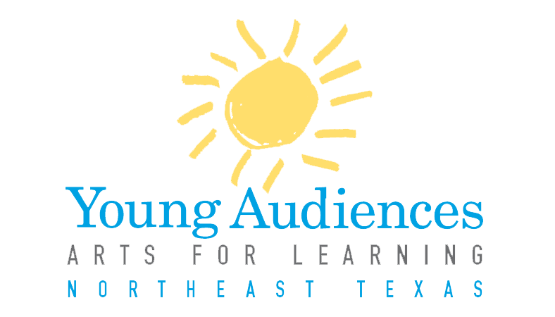

Application Checklist
2017-2018

Application Checklist

  - Contact information
- Completed program submission form (attached). Note: if you are submitting multiple programs for consideration, please fill out a separate form for each.
- Updated resume and 300 word bio.
- Examples of professional work such as photos, audio, and/or video
- The panel must see you working and interacting with children and/or young people; the best way to show this is through digital footage (DVD, YouTube). If digital footage is unavailable, contact Helen Strotman for alternative arrangements.
- Three references with addresses and phone numbers
- Sign and date the application
Application must be typed.

Applications must be postmarked no later than January 2, 2017 to:
Young Audiences of Northeast Texas
Attn: Helen Strotman, Education Program Director
200 East Amherst
Tyler, Texas 7570

YANETX Program New Program Application
Program Type: (Select one.) If submitting applications for more than one program, please fill out a separate form for each.
Assembly Performance Workshop Residency
Program Title:
Musical America: Songs that Shaped our Nation
Grade Levels Targeted: K-2
Technical Requirements:
Ensemble needs an open space with standard Edison plug outlets and enough space to set up three 8ft x 6ft backdrops. Ensemble will need a closed off dressing area that is not a public restroom. Access to a sound system is preferable, but not required.

Please list specific curriculum connections for your program:
Music: Beat, rhythm, audience behavior, and historical context
Social Studies: Holidays, historical figures, and chronology

Instructional Objectives:
The performance described here is designed to introduce or continue students’ knowledge of popular songs that have developed over the course of United States history, alongside the figures and events that helped shape the nation.

Students will hear and sing songs and play musical games including folk songs and patriotic music, and examine the time periods and cultures from which the songs originated.

Students will learn about and practice exhibiting proper audience behavior as it relates to live performance.

Students will learn to identify beat and rhythm, and create or replicate simple musical patterns.

Students will learn the importance of several national holidays such as Independence Day, Veterans’ Day, and Presidents’ Day, as well as customs that go along with these days.

Students will learn to identify important historical figures such as Martin Luther King Jr., George Washington, and learn about their significance in shaping the nation.

Vocabulary Words: Please list 7-10 vocabulary words and their definitions that relate to your program.

Assessment:
To ensure that students have learned the stated objectives, the performance includes several reviews in the style of “check-ins.” Students are asked to show a rhythm that has been talked about, to sing a song with us, or to recognize a song by listening to the rhythm. At the end of the performance, all of the characters we have presented are reviewed again, and students are asked to recall their names and the holidays to which they are connected. We ask the students to call these characters out in order to ensure their mastery of chronology/order of events that we presented.

Additional Resources: Please list any additional resources such as websites, books, articles, etc., that teachers or students may use in connection with your program.

Instructional Plan: Please provide a step-by-step description of your program. Be specific, and do not spare any details. Please use no more than three typed pages. Remember to include:
- Hands-on or student-directed activities that take place; or opportunities for students to actively participate
- How you engage students in your art form
- How you engage students in other subject areas
- Key questions you ask during your program
- Any Pre and/or Post activities that accompany your program
- If your program can be targeted to more than 5 grades, please indicate in your Instructional Plan how you adjust your program to match the age of the audience.

Catalog Description: Please type a 3-5 sentence description of your program for our catalog. A sample description is attached to this packet. YA staff reserves the right to edit descriptions as needed.
The United States of America has a rich history filled with powerful stories and unique characters, and there’s no better way for students to experience it than through song! Join us as we journey through America’s past through some of our most famous songs, all the while learning about the important people and places that happened along the way. Join the All Star performing troupe as they sing

Availability: Please list a statement of your availability, including after school and evenings. Be as specific as possible.

____________________________________ _______________________
Ensemble Leader Signature Date

Sample Catalog Description:
“The world of science is filled with abstract concepts that can be more easily understood when translated into movement. In this residency, students create dances as a way to examine and demonstrate their understanding of science concepts such as atomic structure, DNA replication, and the water cycle. John Doe, choreographer and educator, draws on students’ kinesthetic intelligence for learning in science.”

We recommend that you use the following “breakdown” when creating your catalog description(s): (from the John F. Kennedy Center)
Sentence 1: Educational challenge, rationale, or “sales pitch” about why this art form is a powerful way to learn.
Sentence 2: Specific description of what students will see/do/create.
Sentence 3: Who will lead the program?

Panelist Response Form
2017-2018

Teaching Artist/Ensemble Name: ___________________________________________

Discipline: _____________________________________________________________

Program Name: ________________________________________________________

Performance Workshop Residency
- The proposed program is appealing and educationally valuable to students
1 2 3 4 5
strongly disagree strongly agree

- The objectives stated are appropriate for the targeted grades.
1 2 3 4 5
strongly disagree strongly agree

- The applicant appears to be knowledgeable about his or her arts discipline.
1 2 3 4 5
strongly disagree strongly agree

- The applicant appears to be knowledgeable about the curriculum that the program connects to.
1 2 3 4 5
strongly disagree strongly agree

- The teaching artist’s application looks professional, well organized, and it is clear what they intend to do.
1 2 3 4 5
strongly disagree strongly agree

