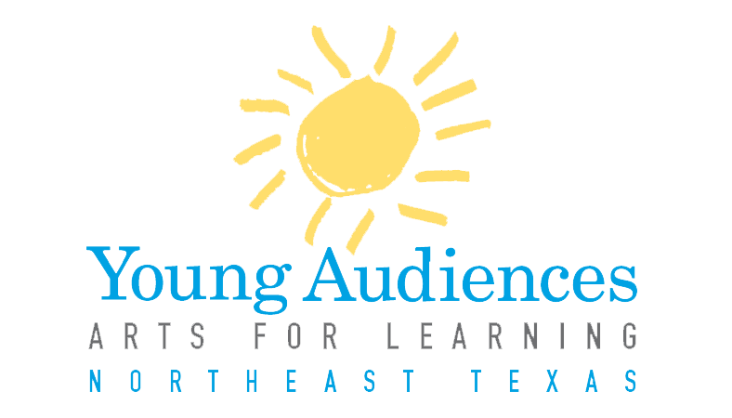

Dear Artists,

Every year Young Audiences of Northeast Texas recruits new programs and artists for its roster. Our current roster features programs in dance, music, visual art, theatre, storytelling, and literary art, led by artists from across Texas. Programs include performances, workshops, residencies, and arts integration professional development for teachers.

Artists in all disciplines are encouraged to submit their arts for learning programs for inclusion in our 2017-2018 roster. Artists on the YANETX roster are advertised year round to schools in the Northeast Texas area, are privileged to professional development through the Young Audiences national network, and other benefits. A panel of arts and teaching professionals will review all applications.

For more information on Young Audiences of Northeast Texas and how to join our roster, visit www.yanetexas.org. or email Helen Strotman, Education Program Director: education@yanetexas.org.

Sincerely,

Young Audiences of Northeast Texas

Teaching Artist Roster Application
2017-2018
Application Deadline
Applications are due no later than January 2, 2017. Applications may be submitted via email to education@yanetexas.org, or mailed to Young Audiences, 200 East Amherst Drive, Tyler, TX 75701. Applications must be postmarked no later than January 2, 2017. All applications must be typed and fully completed; incomplete applications will not be considered.

Timeline:
January 2, 2017: Submission deadline for new artist and new program applications

January 20, 2017: Panel review of fully completed application

February 1, 2017: Notification of application status.

Tips for Submitting a Successful Application:
- Visit www.yanetexas.org and view our mission statement, current programming options, and more information on our organization.
- Strong programs include specific ties to classroom curriculum; including the specific Texas state education standards (which can be viewed here) to which your program aligns is extremely helpful.
- Be sure to use the attached application checklist and provide all support materials requested. In your submitted work samples, the panel must see you working and interacting with children and or young/people; the best way to show this is through digital footage (DVD, YouTube).
- Reference the sample catalog description, and a copy of the criteria our panel members use to evaluate your application, both of which are included in this packet.
- While we will give full consideration to all submitted applications, we are looking to create a culturally diverse roster with a variety of programs across all major arts disciplines, with connections to a variety of classroom curriculum. We have a particular need for programs that connect to and teach literacy skills, reading comprehension, and math skills.
Questions
If you have any further questions, please contact:
Helen Strotman, Education Program Director, (903) 561-2787 or education@yanetexas.org.

New Artist Application Checklist

- Completed New Program Application (attached). Note: if you are submitting multiple programs for consideration, please fill out a separate form for each.
- Updated resume and 300 word bio.
- Examples of professional work such as photos, audio, and/or video
- The panel must see you working and interacting with children and/or young people; the best way to show this is through digital footage (DVD, YouTube). If digital footage is unavailable, contact Helen Strotman for alternative arrangements.
- Three references with addresses and phone numbers
- Sign and date the application

Applications must be postmarked no later than January 2, 2017 to:
Young Audiences of Northeast Texas
Attn: Helen Strotman, Education Program Director
200 East Amherst
Tyler, Texas 75701

YANETX New Program Application
* Items with an asterisk do not need to be completed by artists who are currently on the YANETX roster.
Contact Information* (Current roster artists do not need to complete this section)
Artist/Ensemble Name: _________________________________________________________
Ensemble Leader: _____________________________________________________________
The Ensemble Leader will serve as the direct point of contact with YA for all bookings etc.
Art Discipline: ________________________________________________________________
Address: ____________________________________________________________________
City: ______________________________ State: _______________________ Zip: ________
Home Phone: ____________________________ Work Phone: _________________________
Mobile Phone: ________________________________________________________________
Email: _______________________________________________________________________
Website URL: ________________________________________________________________
Preferred Method of Contact: (select one):
- Email
- Text
- Phone (If you chose phone, please indicate which number is the best way to reach you:)
Home Work Mobile
Are you interested in working with YA to develop custom arts integrated workshops and residencies for schools.
Yes No I’d like more information

Program Information
Program Type: (Select one.) If submitting applications for more than one program, please fill out a separate form for each.
Assembly Performance Workshop Residency
Program Title:

Grade Levels Targeted: We recommend that programs are targeted to grade bands that span no more than five grades. If your program spans more than that, please be prepared to show how you adjust your program to serve different ages.

Technical Requirements: Include items such as sound system, stage, dressing area, etc. Be as detailed as possible.

Please list specific curriculum connections for your program:

Instructional Objectives: What do you want your students to learn? What are the skills you want them to develop? Please state your objectives as “students will….”

Vocabulary Words: Please list 7-10 vocabulary words and their definitions that relate to your program.

Assessment: Please list how you assess a student’s attainment of your previously listed objectives. How do you determine that your students learned the objectives?

Additional Resources: Please list any additional resources such as websites, books, articles, etc., that teachers or students may use in connection with your program.

Instructional Plan: Please provide a step-by-step description of your program. Be specific, and do not spare any details. This description can be in a variety of forms, whether it’s an outline, a script, or a lesson plan. A sample (in outline form) is included later in this packet. Please include:
- How you engage students in your art form (i.e. opportunities for students to participate, hands-on or student directed activities, etc.)
- How you engage students in other subject areas
- Key questions you ask during your program
- Any Pre and/or Post activities that accompany your program

Catalog Description: Please type a 3-5 sentence description of your program for our catalog. A sample description is attached to this packet. YA staff reserves the right to edit descriptions as needed.

Availability:* Please list a statement of your availability, including after school and evenings. Be as specific as possible.

____________________________________ _______________________
Ensemble Leader Signature Date

Sample Catalog Description:
“The world of science is filled with abstract concepts that can be more easily understood when translated into movement. In this residency, students create dances as a way to examine and demonstrate their understanding of science concepts such as atomic structure, DNA replication, and the water cycle. John Doe, choreographer and educator, draws on students’ kinesthetic intelligence for learning in science.”

We recommend that you use the following “breakdown” when creating your catalog description(s): (from the John F. Kennedy Center)
Sentence 1: Educational challenge, rationale, or “sales pitch” about why this art form is a powerful way to learn.
Sentence 2: Specific description of what students will see/do/create.
Sentence 3: Who will lead the residency?

Sample Instructional Plan
Program Title: Musical America: Songs that Shaped our Nation’s History
Artist/Ensemble: Lone Star Minstrels
- Introduction 5 min.
  - Musicians are introduced and ask the audience what they know about America’s songs
  - Musicians decide to help the audience learn about America and her songs through a performance.
    - Questions to audience:
      - What is a performance?
      - What is a performer? Specifically, what is a musician?
      - What is an audience?
      - How do you behave when you’re in the audience?
- Performance/Lesson 30 minutes
  - First Song – Yankee Doodle
    - Introduce the Revolutionary War period and George Washington
    - Discuss where the term “Yankee” comes from
    - Sing Yankee Doodle
  - Second Song – The Star Spangled Banner
    - Introduce the War of 1812 and Francis Scott Key and the story of how/where he wrote the song.
    - Discuss what a National Anthem
    - Discuss when, where, and why we play our national anthem.
    - Explain what you do when the National Anthem is played.
    - Sing the National Anthem
  - Third Song – Nobody Knows the Trouble I’ve Seen
    - Introduce the Civil War era and why the nation was in trouble
    - Discuss Harriet Tubman and her importance in helping slaves get to freedom
    - Discuss how music and singing was an important way to help keep hopes and spirits up
    - Sing Nobody knows the Trouble I’ve Seen
  - Fourth Song – Home Home on the Range
    - Discuss the nation’s expansion and industrialization
    - Discuss what a “beat” is and how this song is written in 3/3 time
    - Have students practice tapping a 3/3 beat
    - Sing Home Home on the Range with students keeping time
  - Fifth Song – This Little Light of Mine
    - Fast forward to the Civil Rights era, and introduce Martin Luther King Jr.
    - Discuss how old words or ideas can be used in a new way to mean something powerful; mention how the song lyrics came to be.
    - Have students practice a 4/4 beat as compared to a 3/3 beat
    - Sing This Little Light of Mine with students keeping time
- Closing 10 minutes
  - Ask students to remember all the songs we sang in order; discuss the importance of chronology and how it relates to history
  - Reintroduce all of the characters we met and the songs they’re tied to
  - Final Song This Land is Your Land
    - Reinforce the notion that America is a large country with a rich history, and that music is a large part of that.
    - Sing This Land is Your Land with the students
  - Bows and goodbyes

Panelist Response Form
2017-2018

Teaching Artist/Ensemble Name: ___________________________________________

Discipline: _____________________________________________________________

Program Name: ________________________________________________________

Performance Workshop Residency
- The proposed program is appealing and educationally valuable to students
1 2 3 4 5
strongly disagree strongly agree

- The objectives stated are appropriate for the targeted grades.
1 2 3 4 5
strongly disagree strongly agree

- The applicant appears to be knowledgeable about his or her arts discipline.
1 2 3 4 5
strongly disagree strongly agree

- The applicant appears to be knowledgeable about the curriculum that the program connects to.
1 2 3 4 5
strongly disagree strongly agree

- The teaching artist’s application looks professional, well organized, and it is clear what they intend to do.
1 2 3 4 5
strongly disagree strongly agree

