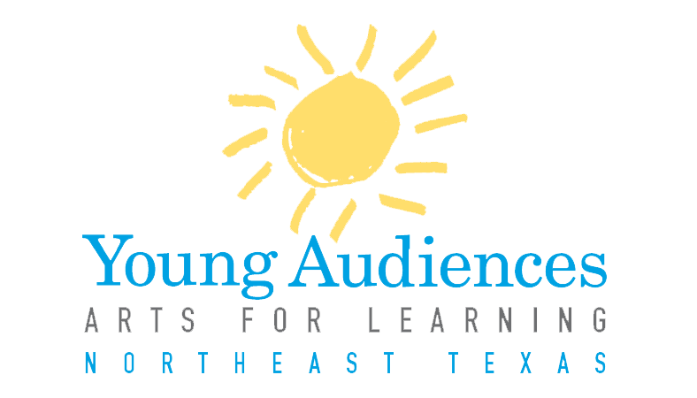

Dear Young Audiences of Northeast Texas Roster Artists,

It’s that time of year again! We are asking for updates from you as we begin to prepare our 2017-2018 Arts in Education Program Guide. As many of you know, this year holds extra significance, as it is our twentieth year serving Northeast Texas.

This year we are asking for a few new pieces of information along with the standard checks that we have your contact information, rate information, and information on your programs correct. Please read through the following packet of information thoroughly, and contact me directly with any questions.

We appreciate your hard work and commitment!

Sincerely,

Helen Strotman
Education Program Director
903-561-2787
education@yanetexas.org

Returning Artist Information Update
2017-2018
Information Deadline
All information is due to Young Audiences no later than February 13, 2017. Documents may be submitted via email to education@yanetexas.org, or mailed to Young Audiences, 200 East Amherst Drive, Tyler, TX 75701. Mailed documents must be postmarked no later than January 2, 2017. If documents are not received by this deadline, artist will not be featured in our 2017-2018 program guide.

Artists who wish to submit a new program to our roster must submit a New Program Application Form, available on our website, which will be reviewed by our program selection panel. Information on this process can be found later in this packet. Applications for new programs must be submitted to Young Audiences no later than January 2, 2017.

Timeline:
January 2, 2017: Submission deadline for new artists and new program applications

January 20, 2017: Panel review of fully completed applications

February 1, 2017: Notification of application status.

February 13th: Submission deadline for current artist information updates and all new artist information documents.

Steps to Updating Your Information
- View the attached “Artist Breakdown,” personalized to each artist/ensemble, that lists your contact information, information on each program you currently offer in our catalog and your current rates. Make any necessary changes.
- Update your program descriptions. In an effort to standardize how our programs are presented, we ask that you view the sample catalog description we have attached, and update your catalog descriptions according to this document. Please note: YA staff reserves the right to edit descriptions accordingly prior to catalog publication.
- Instructional Plan: Please provide a step-by-step description of your program. Be specific, and do not spare any details. This description can be in a variety of forms, whether it’s an outline, a script, or a lesson plan. A sample (in outline form) is available on our website. Please include:
- How you engage students in your art form (i.e. opportunities for students to participate, hands-on or student directed activities, etc.)
- How you engage students in other subject areas
- Key questions you ask during your program
- Any Pre and/or Post activities that accompany your program
- Provide a current study guide for your program; a study guide is a document that can be distributed to campuses prior to your program. This study guide includes activities and suggested lessons that teachers can use to prepare his or her students for your program, and help to tie the information in your program to their classroom curriculum.
- Provide us with a 300 word bio about you as an artist/ensemble to use in our catalog and in marketing.

New Program Application
Artists who are currently on our roster may submit new programs for consideration. To do so, please complete a New Program Application for each program you would like to submit. The application form and information on the process is available on our website.

Questions
If you have any further questions, please contact:
Helen Strotman, Education Program Director, (903) 561-2787 or education@yanetexas.org.

