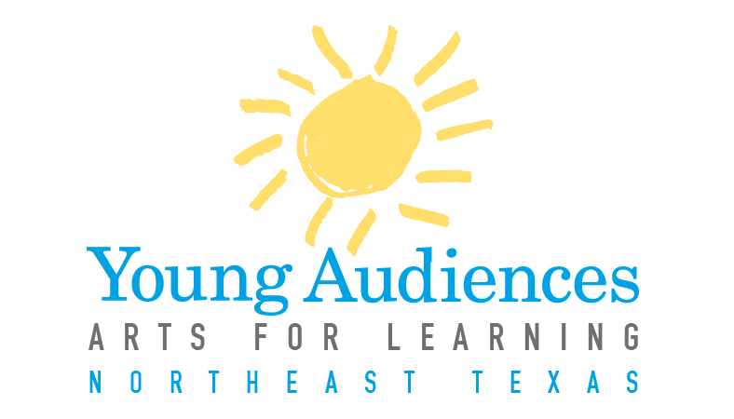

YANETX New Program Application
* Items with an asterisk do not need to be completed by artists who are already on the YANETX roster.
Contact Information* (Current roster artists do not need to complete this section)
Artist/Ensemble Name: _________________________________________________________
Ensemble Leader: _____________________________________________________________
The Ensemble Leader will serve as the direct point of contact with YA for all bookings etc.
Arts Discipline________________________________________________________________
Address: ____________________________________________________________________
City: ______________________________ State: _______________________ Zip: ________
Home Phone: ____________________________ Work Phone: _________________________
Mobile Phone: ________________________________________________________________
Email: _______________________________________________________________________
Website URL: ________________________________________________________________
Preferred Method of Contact: (select one):
- Email
- Text
- Phone (If you chose phone, please indicate which number is the best way to reach you:)
Home Work Mobile
Are you interested in working with YA to develop custom arts integrated workshops and residencies for schools?
Yes No I’d like more information

Program Information
Program Type: (Select one.) If submitting applications for more than one program, please fill out a separate form for each.
Assembly Performance Workshop Residency
Program Title:

Grade Levels Targeted: We recommend that programs are targeted to grade bands that span no more than five grades. If your program spans more than that, please be prepared to show how you adjust your program to serve different ages.

Technical Requirements: Include items such as sound system, stage, dressing area, etc. Be as detailed as possible.

Please list specific curriculum connections for your program:

Instructional Objectives: What do you want your students to learn? What are the skills you want them to develop? Please state your objectives as “students will….”

Vocabulary Words: Please list 7-10 vocabulary words and their definitions that relate to your program.

Assessment: Please list how you assess a student’s attainment of your previously listed objectives. How do you determine that your students learned the objectives?

Additional Resources: Please list any additional resources such as websites, books, articles, etc., that teachers or students may use in connection with your program.

Instructional Plan: Please provide a step-by-step description of your program. Be specific, and do not spare any details. This description can be in a variety of forms, whether it’s an outline, a script, or a lesson plan. A sample (in outline form) can be downloaded from our website. Please include:
- How you engage students in your art form (i.e. opportunities for students to participate, hands-on or student directed activities, etc.)
- How you engage students in other subject areas
- Key questions you ask during your program
- Any Pre and/or Post activities that accompany your program

Catalog Description: Please type a 3-5 sentence description of your program for our catalog. A sample description is attached to this packet. YA staff reserves the right to edit descriptions as needed.

Availability:* Please list a statement of your availability, including after school and evenings. Be as specific as possible.

____________________________________ _______________________
Ensemble Leader Signature Date

